**iPhone and Galaxy Sentiment Analysis**

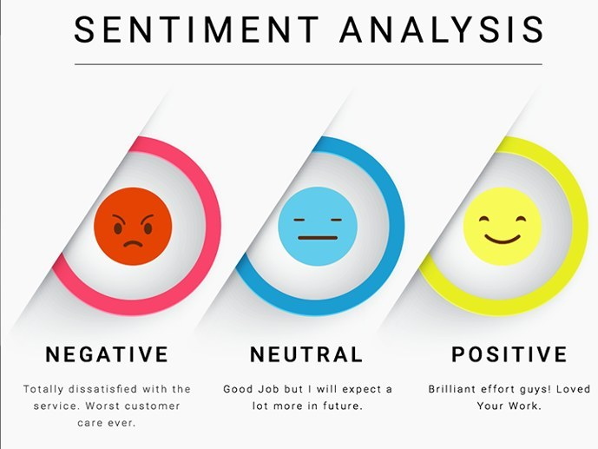

For: Helio

From: Alert! Analytics

Helio, the client, is a smart phone and tablet app developer is working with a government health agency to provide aid to developing countries through the use of medical applications. Helio has narrowed the list of smartphones compatible with their medical apps to five. In order to choose one smartphone from the list of five, Helio has asked Alert Analytics to conduct a sentiment analysis on the corresponding devices. At the end of the analysis, Alert Analytics is tasked with providing a report with the overall attitudes of customers to the smartphones, along with the processes used to arrive at such conclusions.

Our sentiment analysis categorized each user experience under four main categories: very positive, positive, negative and very negative. At the conclusion of our analysis, we noted that more than 9/10 of both iPhone and Galaxy users expressed their experiences at the extreme ends of the spectrum; the users either really loved the experience the smartphone offered or hated the experience. Below are the pie charts showing the sentiment distribution in percentage of the iPhone and Galaxy users.

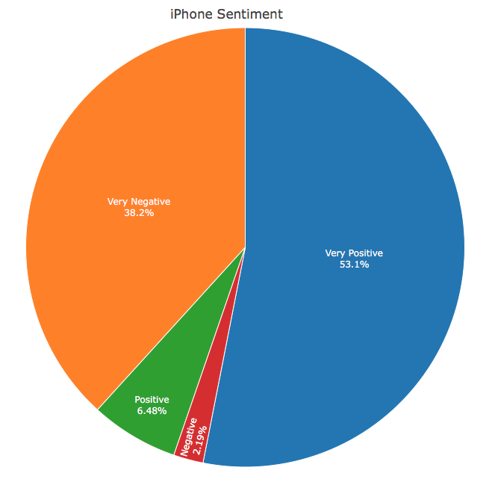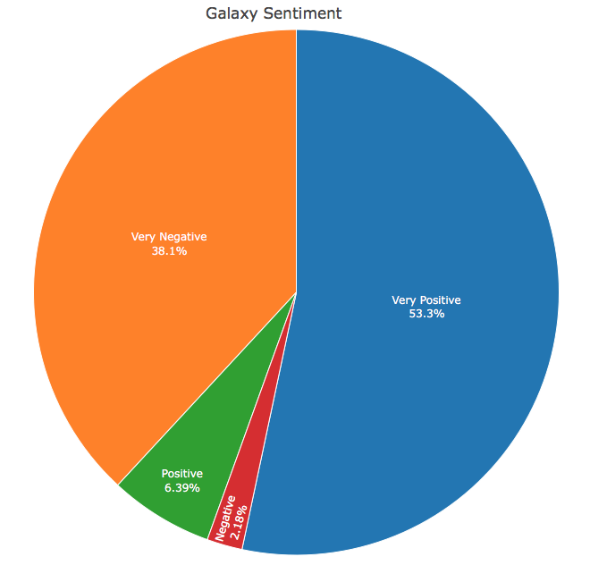

Figure 1: iPhone Sentiment Distribution Figure 2: Galaxy Sentiment Distribution

The figures above illustrate the extreme experiences of the users. For both smartphones, users reported having a very positive experience 53% of the time, and a very negative experience 38% of the time. Leaving less than 9% of user experiences to fall somewhere more neutral.

Table 1: Sentiment Count for both Smartphones

|  |  |  |  |  |
| --- | --- | --- | --- | --- |
| Smartphone | Very Negative | Negative | Positive | Very Positive |
| iPhone | 12,411 | 710 | 2,103 | 17,228 |
| Galaxy | 12,367 | 708 | 2,074 | 17,303 |

Both the pie charts and sentient count tables illustrate the sentiment distribution similarities between both handsets.

When creating models to predict sentiments of each smartphone, a unique predictive model had to be created for each phone. Therefore, the predictions for both smartphones will have different prediction accuracies. For the iPhone sentiment analysis, the model used performed with a correct prediction 0.8401 of the time. The Galaxy sentiment analysis model performed slightly poorer, accurately predicting sentiment 0.8386 of time. However, both round to an accuracy of 84%; this translates to the models predicting the sentiment towards each smartphone correctly at least 4 out of 5 times. Another value shared by both predictive models include a p-value of less than 2.2e-16; this indicates that the relationship used to predict the sentiment of the smartphones is not due to chance.

The Galaxy users reported having a very positive experience 0.2% of the time more than the iPhone user. This would imply that if Helio really wants to have the edge in the technology, they would have to go with the Galaxy. However, because the accuracy of the predictions is not and will never be 100%, I believe the 0.2% difference in user experience is not enough to completely disregard either smartphone brand. The iPhone and Galaxy smartphone offer similar user experience to the user. In the future, we could narrow down the sentiment analysis to user experiences related to the medical field; this way we could analyze what phone is preferred in the medical field.

The first step was collecting relevant articles that expressed sentiments towards the selected smartphones. Text analysis was used to count the number of sentiments mentioned in an article regarding each smartphone’s features; the features included in the text analysis included users’ sentiment toward the phones’ operating system, camera, display and performance. Then we manually labeled the overall sentiment the user had towards both the iPhone and Galaxy phones. This small dataset was then used to train and test models that would predict the overall sentiment based on the smartphone’s feature sentiment, without the help of human labeling. Once we got models that we felt were accurate enough to predict new data, we collected a large sample of unlabeled articles relevant to the iPhone and Galaxy smartphones. Using the models trained with the smaller dataset, we predicted the overall sentiment the article suggested towards the corresponding smartphone. This led to the sentiment count towards the iPhone and Galaxy user experience, whether it landed under Very Positive, Positive, Negative or Very Negative.